Disclosing Administrative Employee Costs

Based on Notes by Dr. Mack Tennyson

Overview

The SDA Accounting Manual requires all receivable costs and compensation associated with Administrative Employees be disclosed separately from all other such costs and compensation.

Besides the Accounting Manual requirements, however, we can come up with a reason using common sense. Administrative Employees are the people who decide how the organization uses its money. It only makes sense that any financial decisions that may benefit these employees be clearly disclosed. Basically, Administrative Employee related costs must be identified and disclosed by category within the Financial Statements.

Administrative Employee Definition

Let’s start by clarifying who is meant by the phrase “Administrative Employee”.

An Administrative Employee is any employee who is serving on the Administrative Committee.

The Administrative Committee includes all of the organization’s officers, as well as any rank and file employee who happens to be assigned to the Administrative Committee. Department heads at many organizations commonly serve on the Administrative Committee.

The inclusion of rank and file employees on the Committee means we need to explore the identity of Administrative Employees a little further. An organization’s officers are, by virtue of their office, on the Committee for the duration of their tenure in their position. Other regular rank and file employees who are asked to serve on the Committee may only serve for a specified length of time before their term ends and someone else’s begins.

For example, Carlo Faraday may be assigned to serve on the Committee from January through April of a given year. In May, he steps down from the Committee and Amandla Bazari holds that position from May through August. Maybe Andrews Karaoke then takes over for September through December of that same year. Each of these three individuals qualifies as an Administrative employee only during the Accounting Periods during which he or she held an active role on the Committee.

System Setup Modifications to Track Administrative Employees

Chart of Accounts

Every month, the Administrative Employees for that Period must be identified in the system. A Memo Type Natural Account must be set up in Chart of Accounts.

The SunPlus convention is to have a ZMADMIN01 Memo Type account. If you need an example of the setup for this account, check the ADA Demonstration Business Unit.

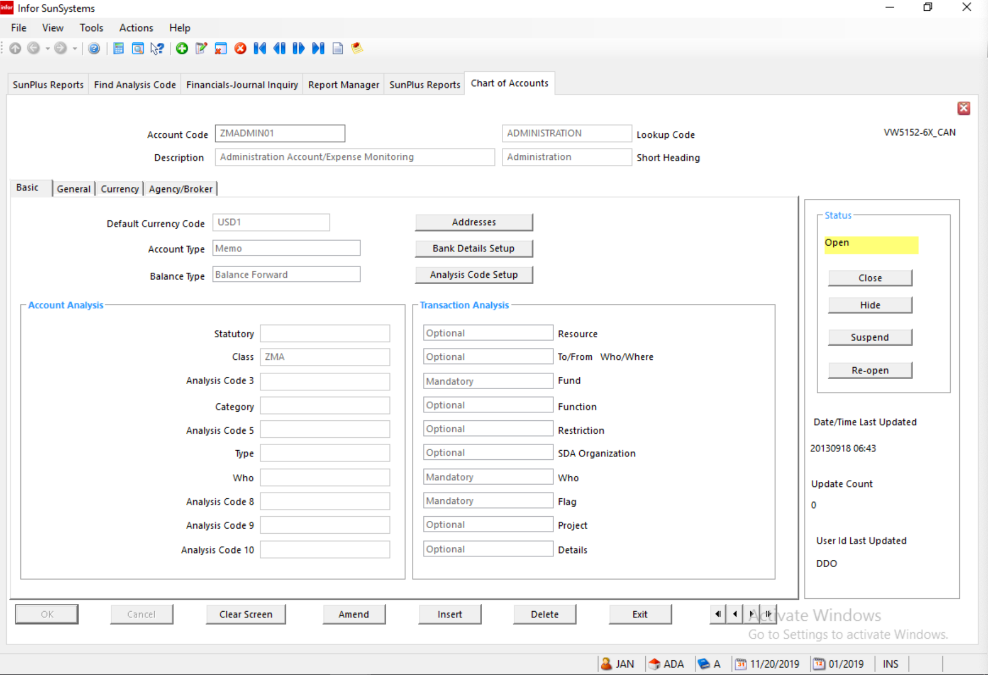

Requirements:
- Account Type Memo
- Balance Type Balance Forward
- Class ZMA
- Transaction Analysis Fund – Mandatory
Who – Mandatory
Flag – Mandatory
- Currency Details Match the organization’s Currency Details

Analysis Codes

FLAG Transaction Analysis codes must include:
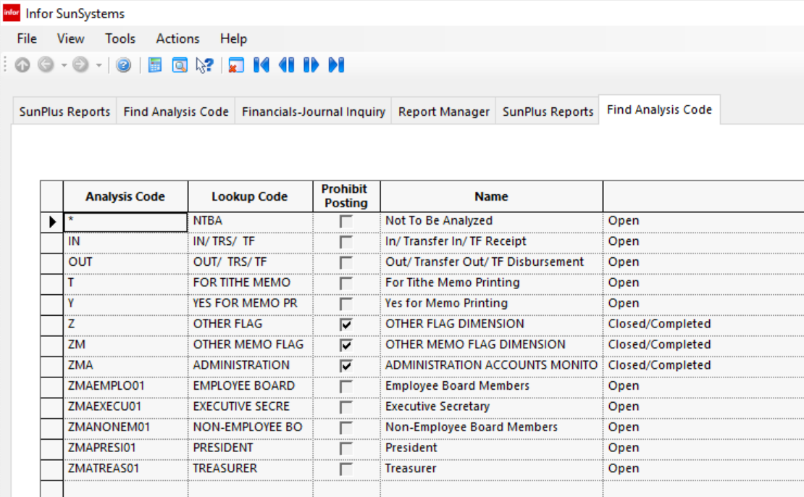

- ZM OTHER MEMO FLAG DIMENSION
- ZMA ADMINISTRATION ACCOUNTS MONITORING
- ZMAEMPLO01 Employee Board Members
- ZMAEXECU01 Executive Secretary
- ZMANONEM01 Non-Employee Board Members
- ZMAPRESI01 President
- ZMATREAS01 Treasurer

Monthly Journal Entry to Record Administrative Employees

Because Administrative Employees are assigned to the Executive Committee for a specified short period of time, those employees must be identified as belonging to the Executive Committee each month during their tenure.

Ledger Entry is used to make that identification.

Every month, make the following entry:
- Journal Type JV
- Accounting Period The relevant Accounting Period
- Account Code ZMADMIN01
- Fund 10
- WHO Employee’s Who Code
- FLAG Choose the appropriate ZMA code for that employee
- Description Employee’s Name and Executive Committee Title
- Memo Amount 1.00
Debit
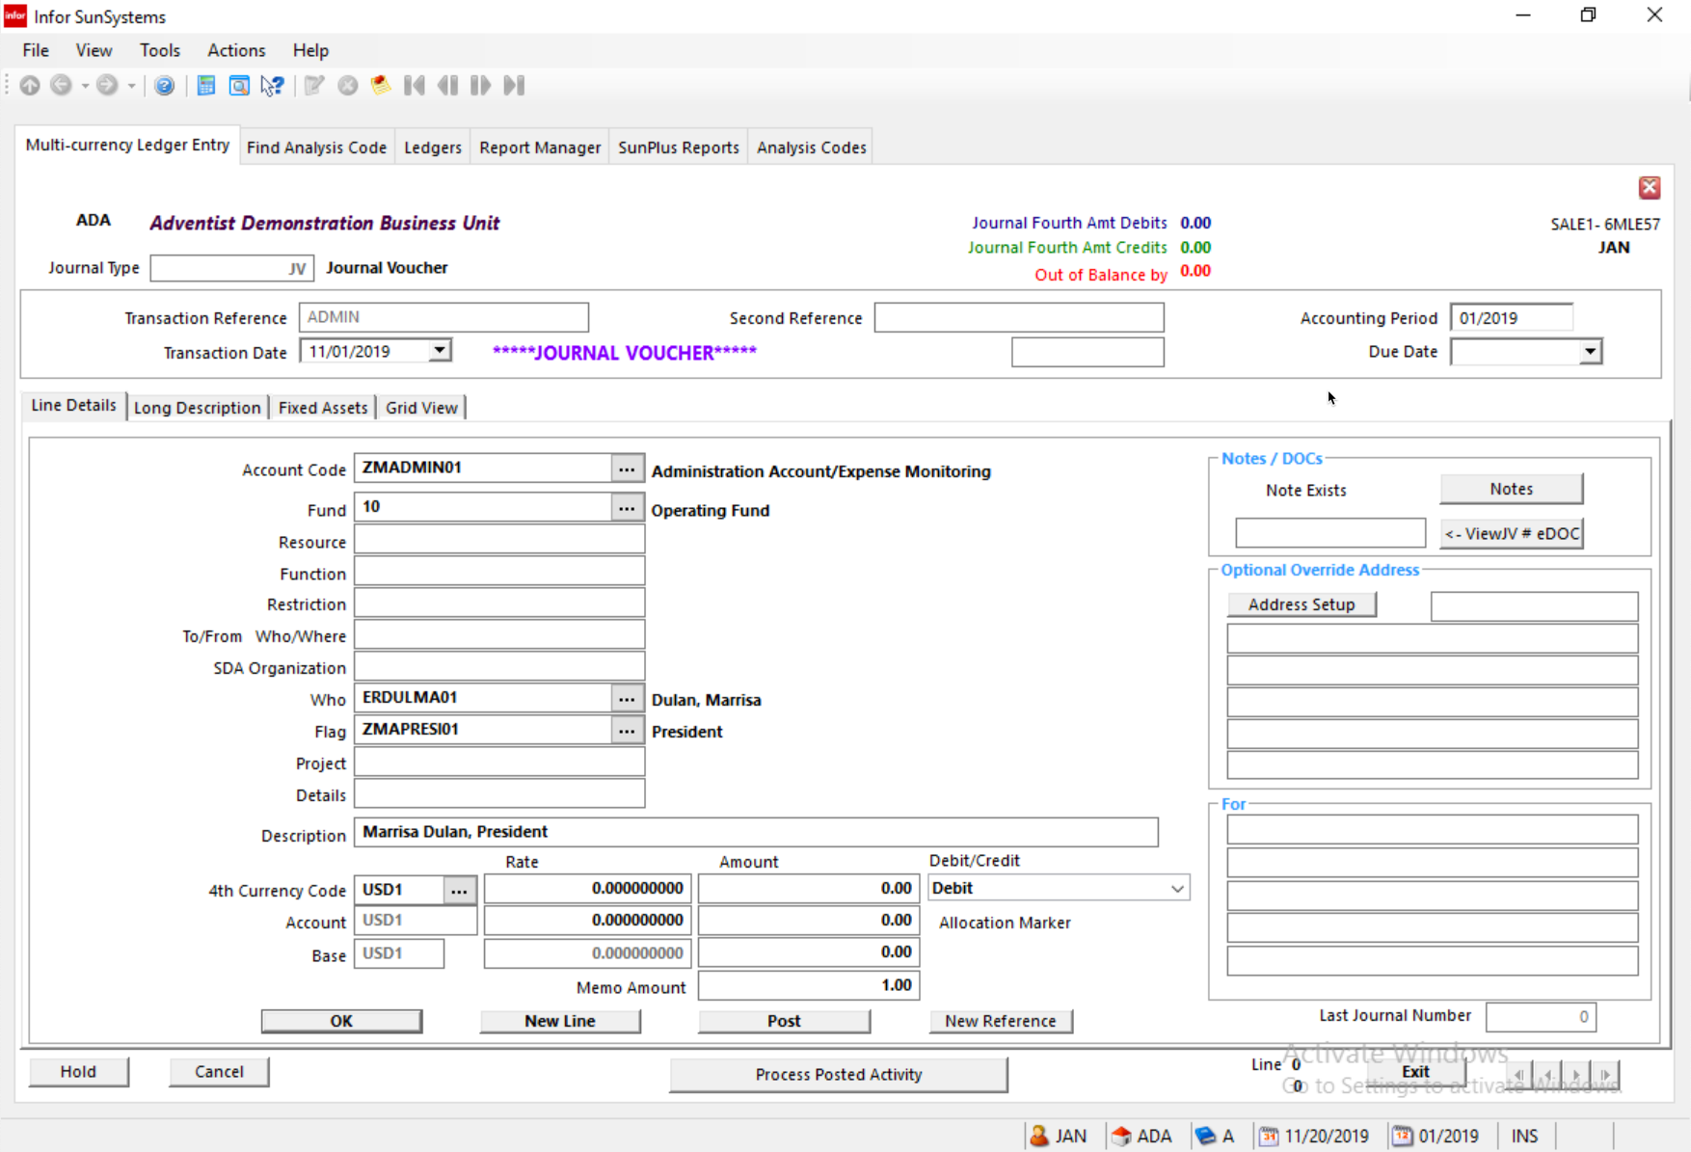
- Click New Line button

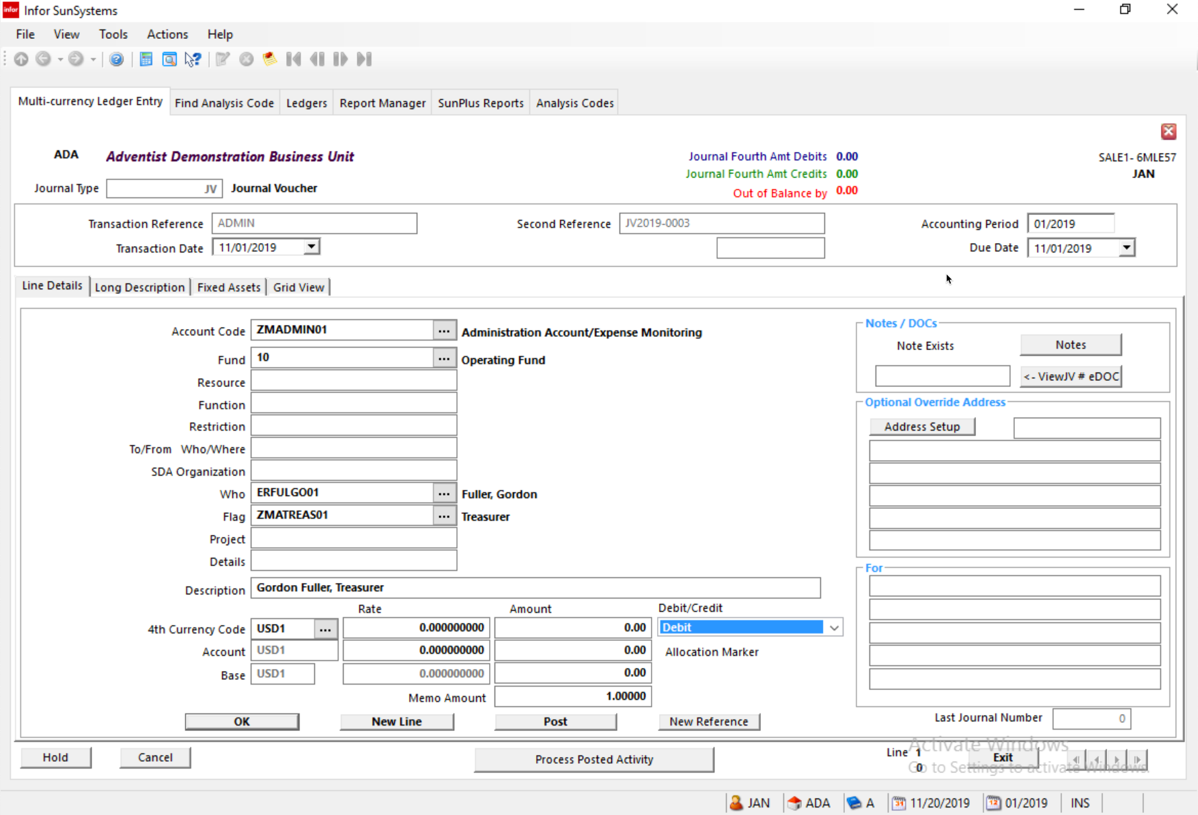
- Enter the details for the next member of the Executive Committee
  - I have entered a line for each type of Executive Committee member, as examples
- Line 3

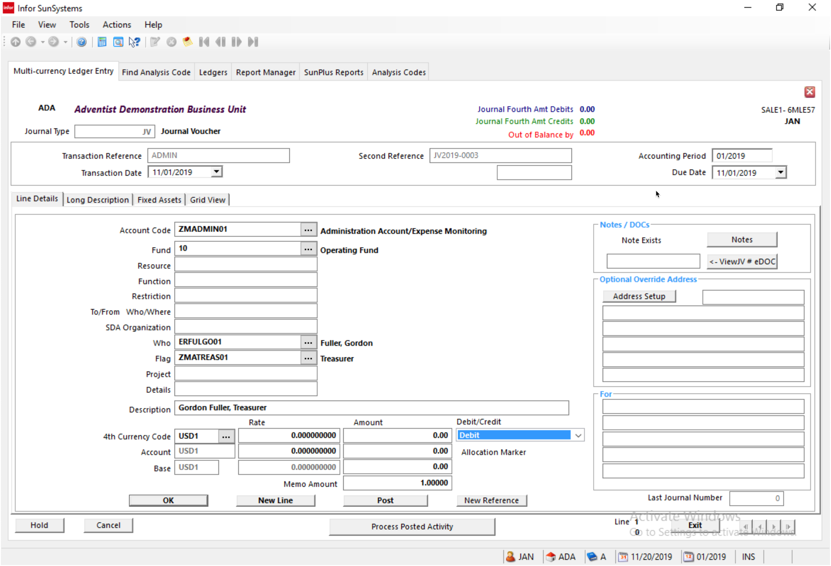
- Line 4

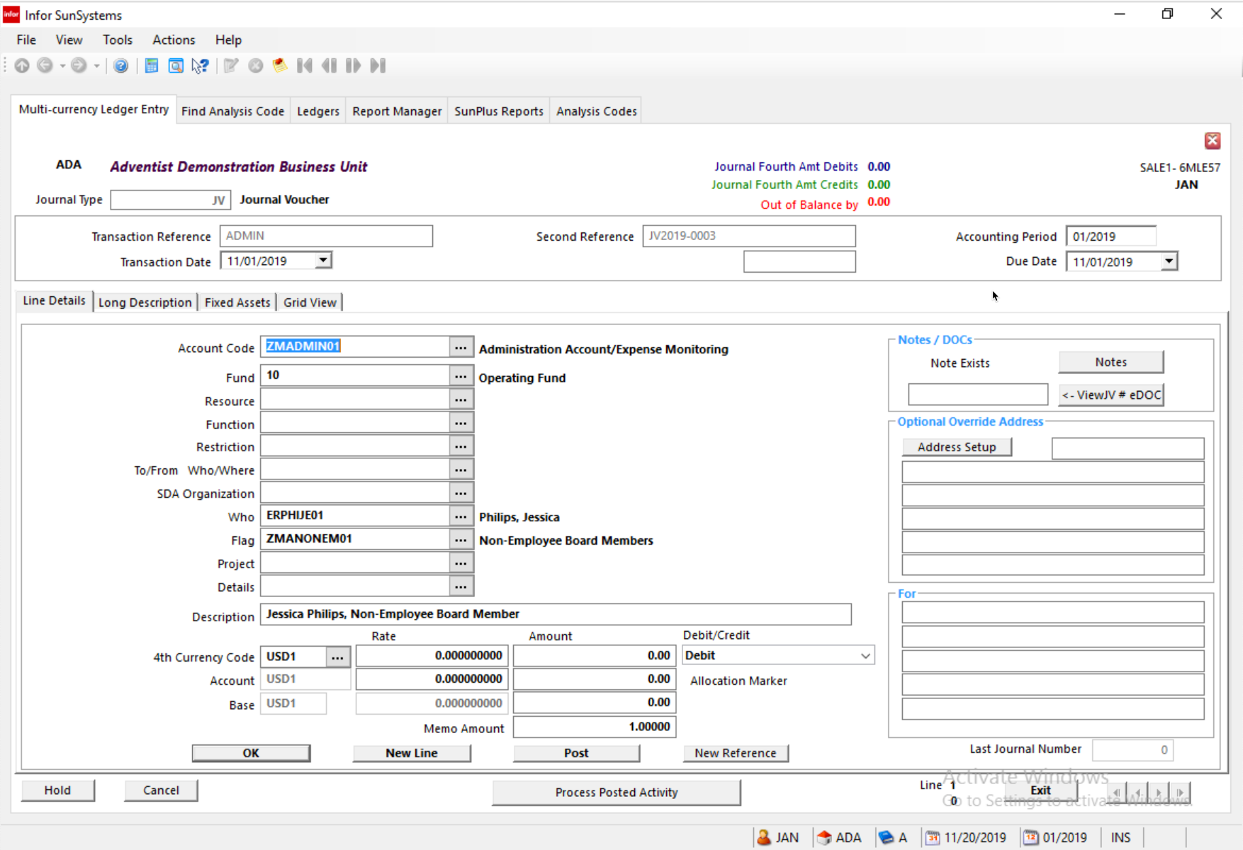
- Line 5
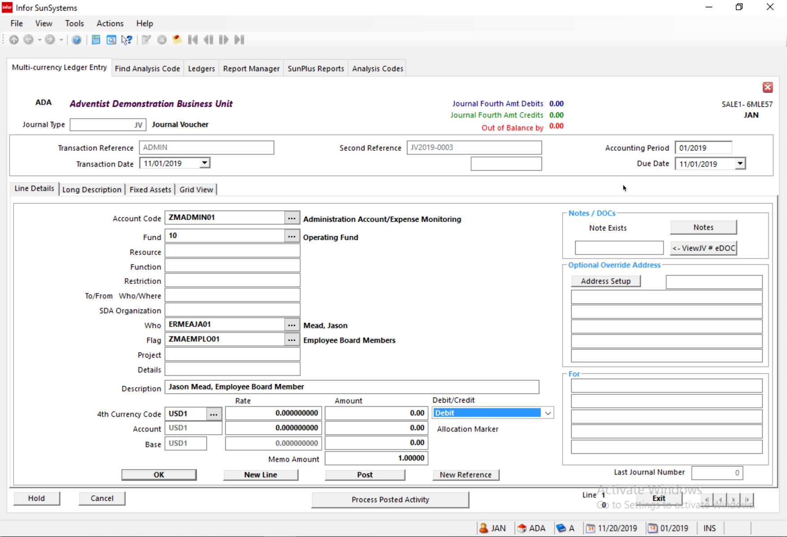
- Line 6

The resulting Journal Listing should look something like this:

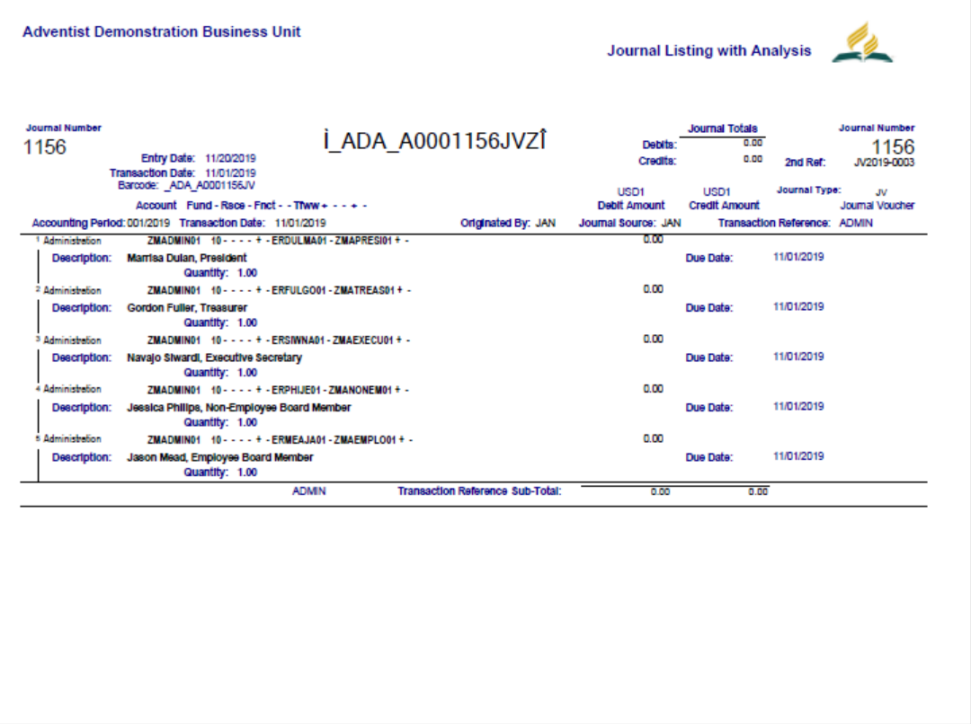

Journal Inquiry

Because the Administrative Employees have been identified in a Ledger Entry, they can be easily pulled up in Journal Inquiry or in a Journal Listing.

Monthly Modifications to Financial Statements

In order for the Financial Statements to be accurate, we need to identify Administrative Employee related costs and then disclose the total of those costs by category within the Financial Statements. This is very important, but simple.

Step One:

Post the Administrative Employees as instructed above.

Step Two:

The Financial Statements will automatically calculate the Account Receivables and Loans for each of the Administrative Employees.

Step Three:

The Financial Statements will automatically calculate the Administrative Employee Expenses.

